Assignment: Frequency Distribution and Visualization of DSA Marks
Group Members:
- Team Leader: Muhammad Hammad Shakeel
- Muhammad Ilyas
- Muhammad Anas Afridi
- Muhammad Ahmed Atif
- Muhammad Rayyan
- Mughira

1. Objective
To analyze the "Percentage" marks of 38 students in Data Structures by calculating a Frequency Distribution and visualizing it using an R-generated bar chart.
2. Methodology & R Code
Step-by-Step Logic:
- Take data then Sort it
- Find Range: from Sorted 38 scores (Min= 0, Max= 97)(start, end) . Range = 97.
- Number of Classes (k): Used Sturges’ Rule [ k=1+(3.3*log10(Range))]. Rounded up to 8 classes.
- Class Width (h): [ Range / k ]. Rounded up to 13.
- Intervals & Plotting: Grouped data into intervals of 13 and plotted the frequencies.
R Code:
rm(list=ls())
m = c( 11.0,15.0,74.0,80.0,67.0,92.0,91.0,12.0,61.0,80.0,5.0,61.0,
8.0,8.0,88.0,15.0,9.0,79.0,11.0,8.0,97.0,16.0,84.0,87.0,97.0,
0.0,60.0,16.0,17.0,17.0,8.0,84.0,9.0,87.0,14.0,87.0,61.0,5.0
)
# Step 1: Sort and find range
ms = sort.int(m)
# Step 2: find Range (max - min)
range = ms[length(ms)] - ms[1]
# Step 3: Calculate classes (k)
k = ceiling(1 + 3.3 * log10(range))
# Step 4: Calculate width (h)
h = ceiling(range / k)
# Step 5: Cut intervals and map frequencies and Plot Bar Chart
xint = seq(0, by=h, length.out=k+1)
x.cut = cut(m, xint)
x.freq = table(x.cut)
barplot( x.freq, xlab="Class Boundaries", ylab="Frequency",
main="Frequency Distribution", col="red", border="black",
ylim=c(0, max(x.freq) + 1))
grid(nx=NA, ny=NULL)

3. BarChart
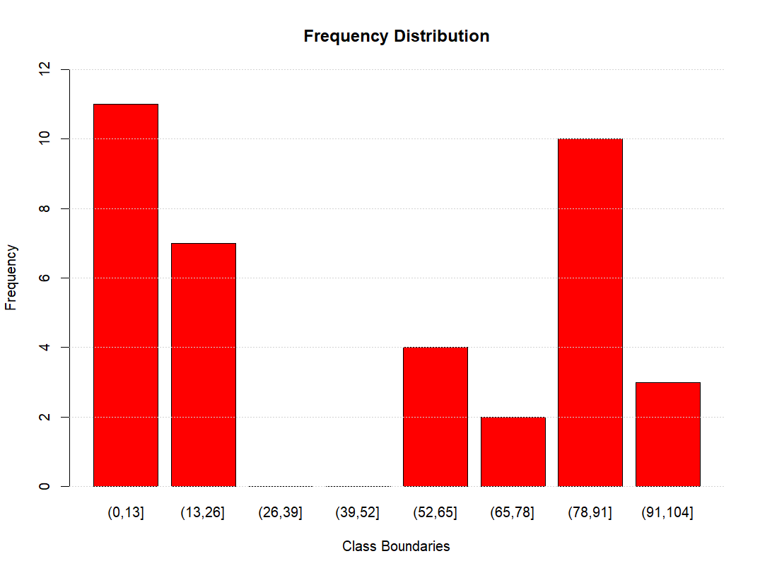
Conclusion: The data shows a polarized, "U-shaped" distribution. A large portion of the class struggled (scores 0-26), while another significant portion performed exceptionally well (scores 78-104), with almost no students in the middle-average ranges.

